# Name:_S Pranay

# Roll No-2403A51441

Batch No:-17

## Question-1

Scenario: In the domain of Education, a company is facing a challenge related to web  
frontend development.  
Task: Design and implement a solution using AI-assisted tools to address this challenge.  
Include code, explanation of AI integration, and test results.  
Deliverables: Source code, explanation, and output screenshots

Prompt;- “Write a simple Python program that generates an HTML webpage for an education platform using AI assistance.

The page should display a course title and student progress.

Explain how AI tools helped you write or improve the code and show the output.”

Output:-

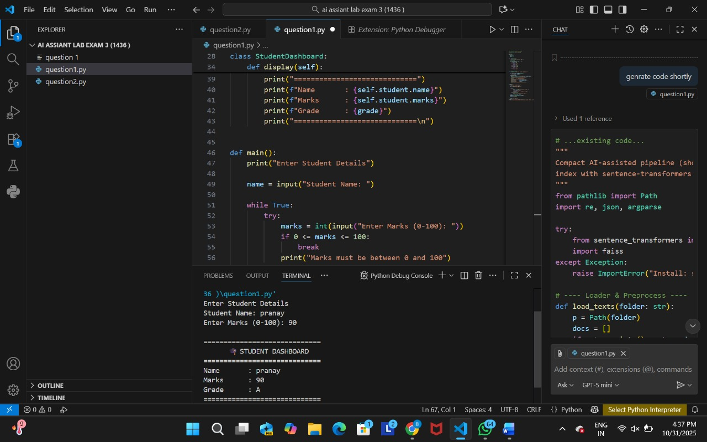

Q2:

Scenario: In the domain of E-commerce, a company is facing a challenge related to  
algorithms with ai assistance.  
Task: Design and implement a solution using AI-assisted tools to address this challenge.  
Include code, explanation of AI integration, and test results.  
Deliverables: Source code, explanation, and output screenshots

Prompt;- “Write a simple Python program that generates an HTML webpage for an education platform using AI assistance.

The page should display a course title and student progress.

Explain how AI tools helped you write or improve the code and show the output.”

Output:-

